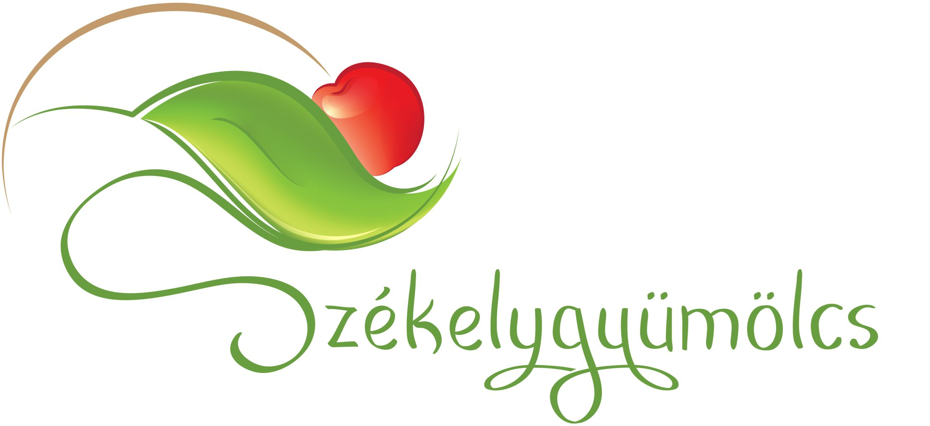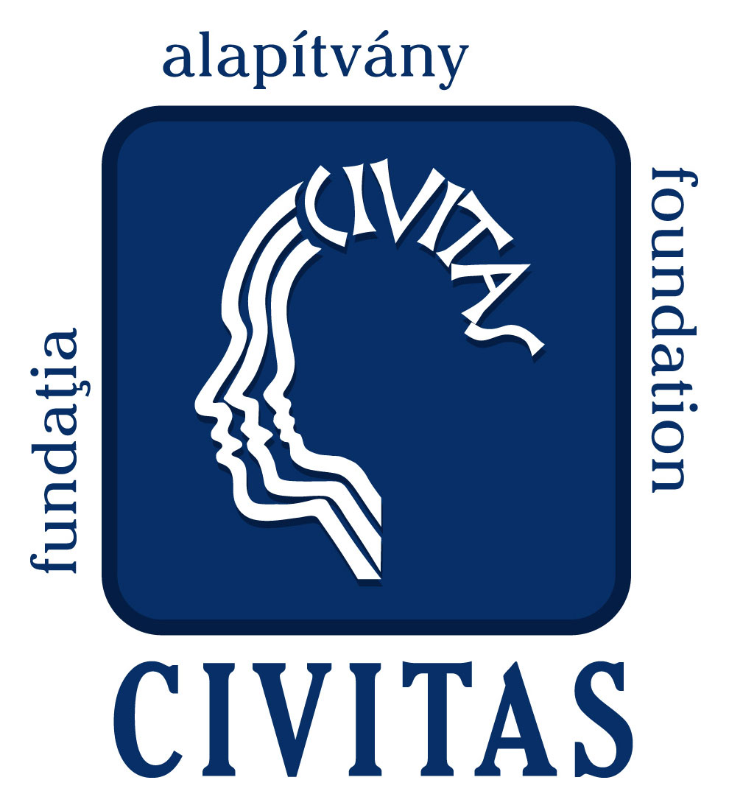

INVITATION

Civitas Foundation for Civil Society and Székelygyümölcs Association are organizing the 3rd Fruit Festival of Odorhei Region and International Conference on 22–25 September, 2011. Last year the events have had a particular success. 150 participants from 9 countries shared their experiences and best practices. During the festival 16 rural communities from Odorhei region exposed their local products from fruit and offered for tasting more than 200 different types of jams and special products. In the workshops and study visits were initiated discussions and collaborations between participants. On behalf of the organizers we kindly
invite
You and Your colleagues to participate to the events in order to enrich the knowledge base and to enhance the cooperation opportunities by joint efforts and common willingness.
The event would offer an opportunity to place to its worthy position the economy based on sustainable use of natural resources as well as active implication of rural communities in these development processes. In the same time, this event will offer a great opportunity for collaboration between experts from Europe interested in community-based economic developments to assist launching and consolidation of viable initiatives. Based on these guidelines we organize an international conference. The main topic of the Conference is:

Community-based rural economic development in Europe.
The LEADER program has started in Romania too, after a selection procedure of the LAGs. The Conference and the Festival would offer a great opportunity to know each other and to initiate collaboration between Romanian and European LEADER Action Groups.
Please confirm your participation by filling-in the enclosed registration form and sending it to the following e-mail istvanmar@civitas.ro or to the address of our Foundation until 5th September:

Civitas Foundation for Civil Society
535600 Odorheiu Secuiesc, Solymossy str. 29. no.
Tel./Fax: +40-266-218-481

Warmest regards:
Orbán Árpád Már István
Civitas Foundation Székelygyümölcs Association
Regional director president

