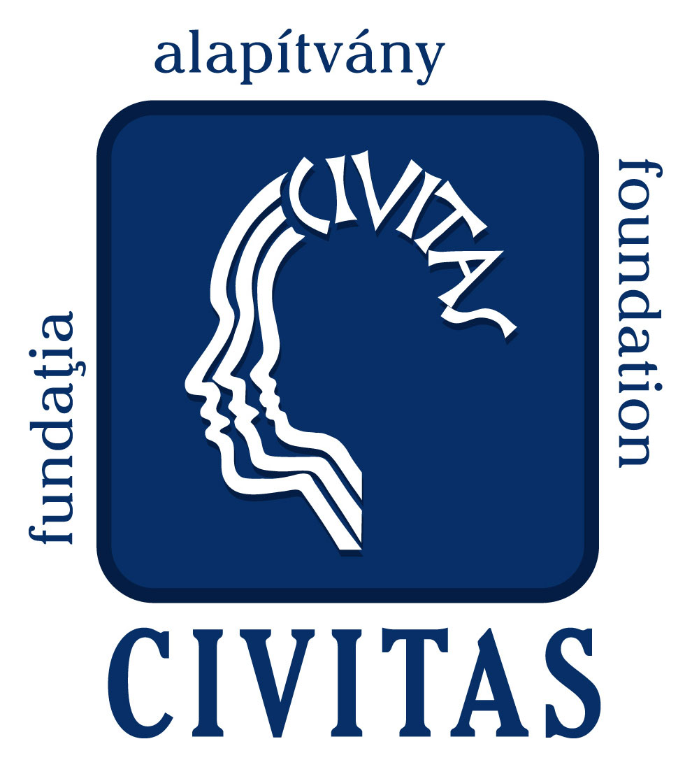

3rd Fruit Festival of Odorhei Region
Odorheiu Secuiesc, 22-25 September, 2011.

Community-based RURAL economic development In europe
– International conference and program –
Cultural House – Odorheiu Secuiesc, Tamási Áron str. 15.

REGISTRATION FORM

Deadline for submission: 5th September, 2011.

Organization/Institute/Leader LAG name:
Name of participant: Position:
Address:
Telefon: Fax: Mobile:
E-mail: Website:
Please, mark by X, if you would like to participate on the conference on 22nd September. The participation on the conference is conditioned by a registration fee. This includes the hardcopy of presentations, attendance to coffee break, lunch and dinner during the conference.

Registration fee:
- 1 person – 60 euro
- 2 person – 100 euro
- LEADER Action Group (up to 4 person): 200 euro
For each further person the registration fee is 50 euro/person.

Number of participants: persons

Please, mark by X to which workshop would you like to participate:

Connections between local product and rural tourism

International collaborations between European LEADER Action Groups

Please, mark by X, if you would like to participate on short study visit on 23rd September. The participation to the visit tour is conditioned by a registration fee. This includes travel, professional program and lunch.

Registration fee for the study trip: 20 euro/person

Number of participants: persons

The participation to the Conference and field study trip is conditioned by receiving the filled-out registration form and by transferring the registration fee.
The deadline for submission is 1st August, 2011.

Name of the Bank: BRD Sucursala Odorheiu Secuiesc
Bank account number: RO16BRDE210SV00927502100 (EUR)
SWIFT code: BRDEROBU
Name of account holder: Fundatia Civitas pentru Societatea Civila
Address of account holder: 535600 Odorheiu Secuiesc, str. Bethlen Gabor nr. 43, Romania
Tax number: 4559545

Please, send with your filled registration form the copy of the bank transfer document.

Reservation for accommodation
The organizers would like to assist the participants to make the most convenient reservation for accommodation. Please mark below the type and the period you would like to have accommodation in Odorheiu Secuiesc (according to special request the organizers should prepare personalized offers!):

Hotel***, 35 €/day/person, including breakfast (accommodation in double rooms)

Pension***, 25 €/day/person, including breakfast (accommodation in double rooms)

Rural pension, 20 €/day/person, including breakfast (accommodation in double rooms)

Days of reservation

Wednesday, 21st September yes no
Thursday, 22nd September yes no
Friday, 23rd September yes no
Saturday, 24th September yes no
Sunday, 25th September yes no

For booking reason there need to pay the 30% of accommodation cost with registration fee by 5th September.

